SMART ECOBIN
An IoT-Based Automatic Waste Segregation and Fill-Level Monitoring System
Project Report

Prepared by
M. Jayantha Siva Srinivas
B.Tech, Electronics and Communication Engineering

Design & Simulation Platform: Cirkit Designer
Controller: Arduino Uno R3
July 2026

Table of Contents
Abstract 3
1. Introduction 3
2. Objectives 3
3. System Overview 3
4. Hardware Components 4
5. Circuit Design 4
5.1 Pin Mapping …..5
6. Working Principle 6
6.1 Initialization and Ready State 6
6.2 Waste Detection and Lid Operation …….6
6.3 Automatic Waste Segregation 7
6.4 Compartment Fill-Level Monitoring and Alerts 7
7. Design and Simulation Tool — Cirkit Designer 9
8. Advantages 9
9. Applications 9
10. Limitations 9
11.Future Scope…………………………………………………………9-10
11. Conclusion 10

Abstract
Improper segregation of household and public waste at the point of disposal remains a major obstacle to effective recycling and waste management. Smart EcoBin addresses this at the source: an Arduino Uno–based dustbin that opens its lid automatically when waste is presented, senses the moisture content of the material as it falls, and mechanically diverts it into a dedicated wet or dry compartment. A pair of dedicated ultrasonic sensors continuously watches the fill level of each compartment and raises a distinct, unmistakable beep pattern — one beep for dry, two for wet, three when both are full — supported by real-time status messages on an onboard OLED display. The complete circuit was designed and functionally simulated in Cirkit Designer before being finalised. The result is a low-cost, low-maintenance system that removes the guesswork from manual sorting and gives a caretaker a clear, audible signal for when the bin needs attention.

1. Introduction
Municipal and household waste is overwhelmingly disposed of as a single mixed stream, even though a large share of it — kitchen scraps, garden waste, liquids — is wet, while paper, plastic and packaging is dry. Once mixed, the two categories are difficult and unpleasant to separate downstream, which discourages recycling and increases the volume that ends up in landfills. At the same time, bins are typically emptied on a fixed schedule rather than when they are actually full, leading either to premature collection trips or to overflow between visits.
Smart EcoBin is a compact embedded system that tackles both problems together. It automates the physical act of segregation at the moment waste is dropped in, and it replaces guesswork about fill status with an unambiguous audible and visual alert, specific to whichever compartment needs emptying.

2. Objectives
- Open the main lid automatically and touch-free whenever waste is presented in front of the bin.
- Classify each piece of waste as wet or dry using a capacitive moisture sensor and route it accordingly using a servo-actuated flap.
- Continuously monitor the fill level of the dry and wet compartments independently.
- Raise a distinct beep-coded alert — 1 beep (dry full), 2 beeps (wet full), 3 beeps (both full) — so a caretaker instantly knows which side needs attention without checking manually.
- Provide constant, human-readable status feedback on an onboard OLED display at every stage of operation.

3. System Overview
The system is built around an Arduino Uno R3, which is the sole decision-making unit. It reads three independent HC-SR04 ultrasonic sensors, one capacitive moisture sensor, and drives two SG90 micro servos, a piezo buzzer and an I2C OLED display. The three ultrasonic sensors are deliberately given three separate roles rather than one shared role:
- Bottom sensor — faces outward at the front of the bin and exists purely to detect an approaching hand or object, which triggers the lid.
- Top-left sensor — mounted inside the dry compartment, facing down, to measure how close the waste has piled up to the sensor (i.e. how full that side is).
- Top-right sensor — the same idea, mounted inside the wet compartment.
This separation keeps the lid-opening logic completely independent of the fill-level logic, so one cannot interfere with the other.

4. Hardware Components

Component | Qty | Function in the System
Arduino Uno R3 | 1 | Central controller — reads all sensors and drives the servos, buzzer and OLED
HC-SR04 Ultrasonic Sensor | 3 | One triggers the main lid; the other two monitor fill level in the dry and wet compartments
Capacitive Soil Moisture Sensor | 1 | Detects whether incoming waste is wet or dry
SG90 Micro Servo Motor | 2 | One operates the main lid; the other actuates the dry/wet diverter flap
Piezo Buzzer | 1 | Sounds distinct beep patterns for compartment fill-level alerts
0.96" OLED Display (SSD1306, I2C) | 1 | Shows live system status and instructions to the user

5. Circuit Design
The complete schematic — Arduino Uno, three HC-SR04 modules, the moisture sensor, both SG90 servos, the buzzer and the OLED — was laid out and wired in Cirkit Designer, which was also used to functionally simulate the system's behaviour prior to finalising the build.
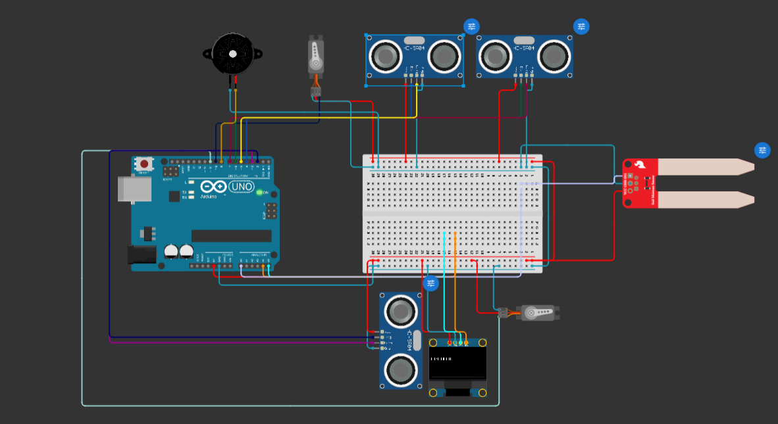
Figure 1 — Complete circuit layout in Cirkit Designer

5.1 Pin Mapping
Signal | Arduino Pin | Role
Bottom Ultrasonic — Trig / Echo | D2 / D3 | Detects an object near the main lid opening
Dry-Side Ultrasonic — Trig / Echo | D4 / D5 | Monitors fill level of the dry compartment
Wet-Side Ultrasonic — Trig / Echo | D6 / D7 | Monitors fill level of the wet compartment
Buzzer | D8 | Audible fill-level alerts
Diverter Flap Servo | D9 | Routes falling waste to the wet or dry side
Lid Servo | D10 | Opens and closes the main lid
Moisture Sensor | A0 | Analog reading used to classify wet vs. dry waste
OLED Display | SDA / SCL (I2C) | Status display, address 0x3C

6. Working Principle

6.1 Initialization and Ready State
On power-up, the OLED briefly displays a startup message while the servos move to their default positions — the lid closed and the diverter flap centred. The system then settles into an idle “ready for waste” state and continuously polls the front-facing sensor.
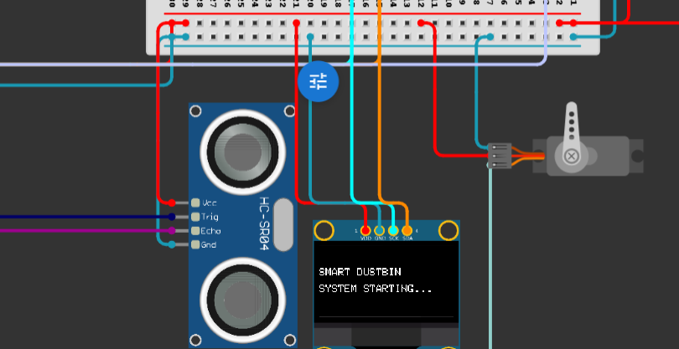
Figure 2 — System initialization message
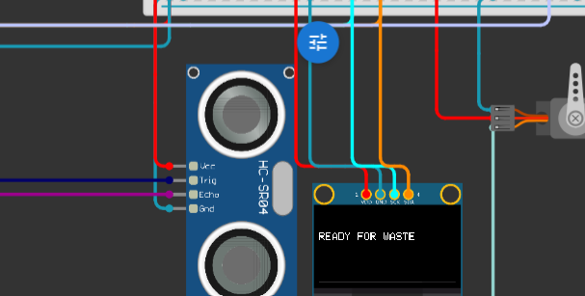
Figure 3 — Idle / ready-for-waste state

6.2 Waste Detection and Lid Operation
When the bottom ultrasonic sensor detects an object within its trigger distance, the lid servo swings the lid open. It stays open briefly to allow the waste to be dropped in, then closes automatically, after which the system moves straight into the segregation step for whatever has just fallen in.

6.3 Automatic Waste Segregation
As the waste passes the moisture sensor, the reading is compared against a set threshold. If it is classed as wet, the diverter flap servo swings toward the wet compartment; if dry, it swings the opposite way toward the dry compartment. In both cases the OLED confirms the classification, and the flap returns to a neutral centre position immediately afterward, ready for the next item.
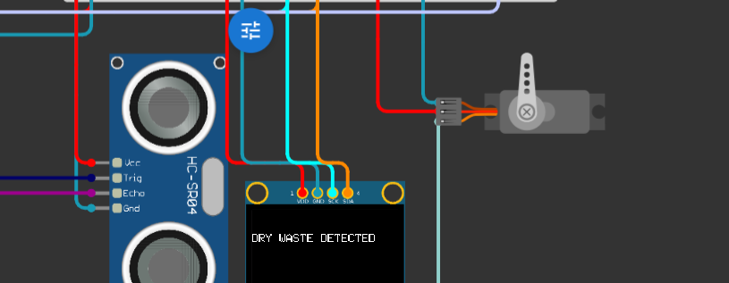
Figure 4 — Dry waste detected and routed
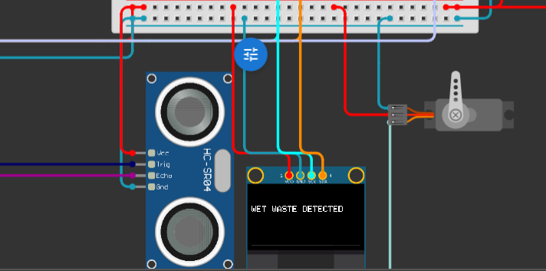
Figure 5 — Wet waste detected and routed

6.4 Compartment Fill-Level Monitoring and Alerts
Independently of the lid and segregation logic, the two top-mounted ultrasonic sensors are polled continuously to measure how close the waste pile is to each sensor. Once a compartment crosses the full-level threshold, the buzzer sounds a beep pattern unique to that condition, and the OLED switches to a persistent status message naming the compartment that needs to be emptied. Each alert fires only once per full event rather than repeating on every loop, so the buzzer does not sound continuously while the bin sits full.
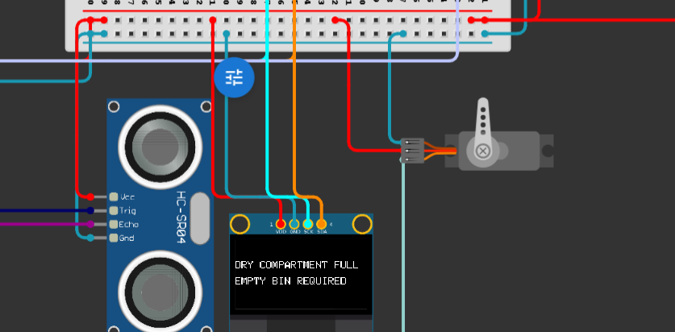
Figure 6 — Dry compartment full — single beep
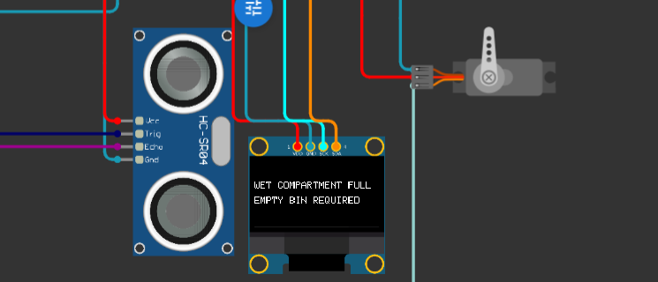
Figure 7 — Wet compartment full — double beep
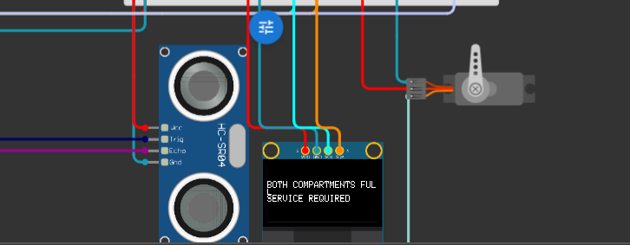
Figure 8 — Both compartments full service required — triple beep

7. Design and Simulation Tool — Cirkit Designer
Cirkit Designer was used end to end for this project: placing and wiring every component (Arduino Uno, the three HC-SR04 sensors, the moisture sensor, both servos, the buzzer and the OLED), and then running the design to confirm that the lid, segregation and alert logic behaved as intended before treating the design as final.

8. Advantages
- Touch-free lid operation reduces contact with a potentially unhygienic surface.
- Segregation happens automatically at the point of disposal, rather than relying on the user to sort correctly.
- Distinct beep codes mean a caretaker knows which compartment is full without opening or inspecting the bin.
- Constant OLED feedback makes the system's state clear at every step, aiding troubleshooting and everyday use.
- Built entirely from low-cost, widely available components (Arduino Uno, HC-SR04, SG90, SSD1306 OLED).

9. Applications
- Households and residential complexes
- Office spaces, cafeterias and common areas
- Educational institutions and hostels
- Public spaces and parks as part of a smart-city waste initiative

10. Limitations
- The system currently operates standalone; there is no wireless reporting of fill status to a remote dashboard or to municipal staff.
- Waste is classified using a single moisture reading at the point of drop, which may reduce accuracy for borderline items.
- Mechanical wear on the SG90 servos over extended, high-frequency use would need to be monitored in a long-term deployment.

11.Future Scope
- Adding a Wi-Fi module (e.g. ESP8266/ESP32) would allow remote monitoring and notifications to municipal staff or a caretaker.
- Additional sensing (e.g. weight, or multiple moisture readings) could improve waste classification accuracy.
- Solar or battery-backed power could be added for deployment in outdoor or off-grid locations.
- A mobile app or web dashboard could let users track compartment fill levels and collection history remotely.
- GPS and cellular connectivity could enable fleet-level tracking of multiple bins across a locality for smart-city waste collection routing.

12. Conclusion
Smart EcoBin demonstrates that a small, low-cost sensor and actuator set — three ultrasonic sensors, a moisture sensor, two micro servos, a buzzer and an OLED, all driven by a single Arduino Uno — is enough to automate both waste segregation and fill-level reporting in one device. By designing and validating the full circuit in Cirkit Designer beforehand, the project moved from concept to a working, testable system with a clear path toward further IoT connectivity in future revisions.

